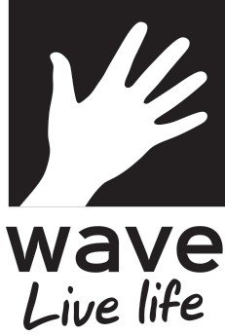

- Please provide the following details:
Post Code:

Organisation Name
(if applicable)
Contact Name

Address

Contact Number Email address

- Please state the amount of grant funding you are applying for (£)

- Which geographical area would any grant funding benefit?
(please select from the following):
Lewes
Newhaven
Seaford
Peacehaven
Other (please specify)

- If successful, the Grant Funding would be used for? (please select one of the following):
Continual Funding of an existing ongoing activity
To fund an existing organisation in setting up a new activity
The creation of a new organisation and activity
An individual

- If Wave are not able to fully fund your application, would partial funding be beneficial?
Yes
No
  - If you have ticked ‘yes’ please provide details of how the application will be fully funded.

- Is this application also being considered by other funding sources?
Yes
No

  - If you have ticked ‘yes’ please provide details below.

- Please provide details below of how any funding awarded will be used.
You may use additional sheets if required and please supply copies of any estimates/quotes for equipment to substantiate your request.

Signature

Print Name

Date

Completed application forms must be returned by Friday 29th March 2019. Successful applicants will be notified by Thursday 18th April 2019. If you have not heard from Wave regarding your application by Thursday 18th April 2019 your application was unfortunately unsuccessful. Please direct any enquiries regarding the Wave Community Fund to kevin.calmiano@waveleisure.co.uk or call 01323 493064.

